**Project Design Phase-II**

**Technology Stack (Architecture & Stack)**

|  |  |
| --- | --- |
| Date | 31 January 3035 |
| Team ID | LTVIP2025TMID51556 |
| Project Name | Visualizing Housing Market Trends: An Analysis of Sales |
| Maximum Marks | 4 Marks |

**Technical Architecture:**

The Deliverable shall include the architectural diagram as below and the information as per the table1 & table 2

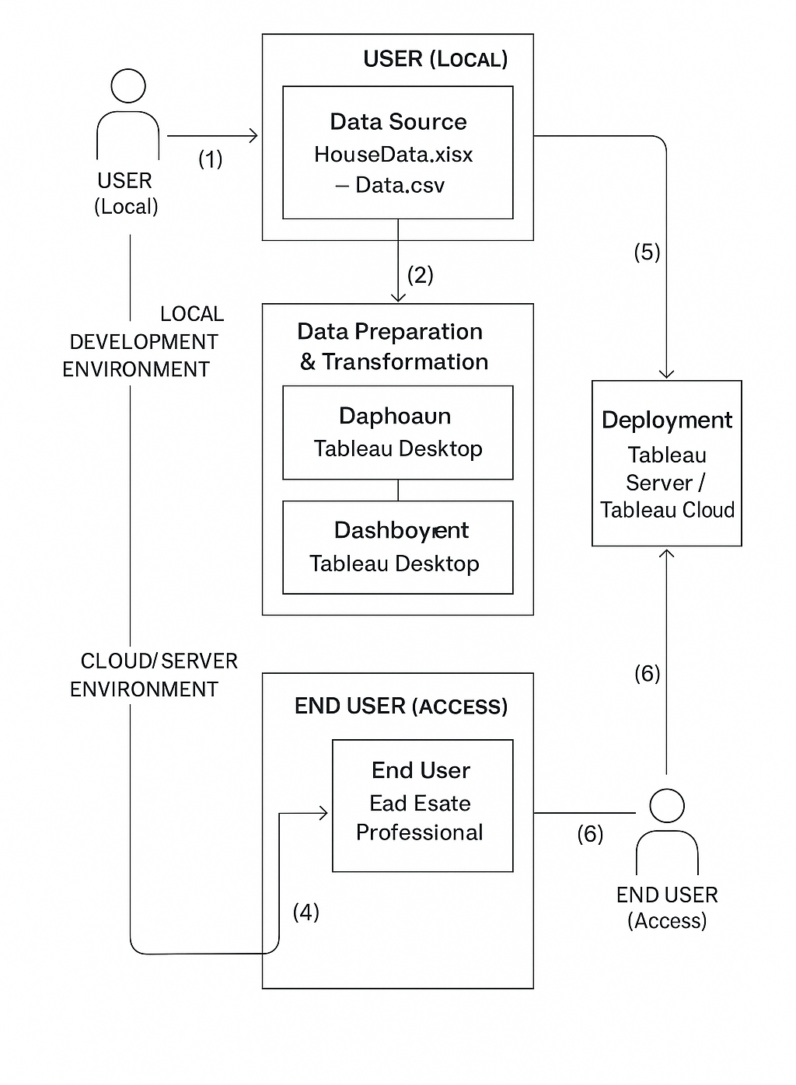

**Table1: Components & Technologies**

|  |  |  |  |
| --- | --- | --- | --- |
| S.NO. | Component | Description | Technology |
| 1. | User Interface | How users interact with the solution. | Tableau Dashboard / Story |
| 2. | Application Logic-1 | Core data processing and calculations. | **Tableau Desktop** |
| 3. | Application Logic-2 | Data preparation | **Tableau prep** |
| 4. | Application Logic-3 | analytics/scripting. | **Integration** within Tableau |
| 5. | Database | Where primary data is stored. | **Local CSV File(s) / Tableau Data Extracts** |
| 6. | Cloud Database | Cloud-based data storage (if used). | **N/A** (Not applicable for current CSV source) |
| 7. | File Storage | Storage for source files. | Local File system |
| 8. | External API-1 | Any external data integrations. | None |
| 9. | External API-2 | Additional external integrations. | None |
| 10. | Machine Learning Model | Any ML models utilized. | None |
| 11. | Infrastructure | Environment for development and deployment. | **Tableau Desktop / Tableau Public / Tableau Server / Tableau Cloud** |

**Table-2: Application Characteristics**

|  |  |  |  |
| --- | --- | --- | --- |
| S.NO. | Characteristics | Short Description | Technology |
| 1. | Open-Source Frameworks | Used for data cleaning and extended analysis. | Tableau prep |
| 2. | Security Implementations | Secure user access, roles, and data integrity. | **Tableau Server/Cloud Security** (Auth, RBAC, RLS) |
| 3. | Scalable Architecture | Designed to handle growing data and users. | **Tableau Server/Cloud** (Multi-node, Hyper) |
| 4. | Availability | Ensures dashboard is consistently accessible. | **Tableau Server/Cloud HA,** Scheduled Refreshes |
| 5. |  | Fast loading and responsive interactions. | **Tableau Optimizations** (Hyper, efficient design, server resources) |